Process Modelling using Lucidchart

Project Name: Healthfirst Care Capstone Project
Project Manager: Seth Haynes

Current Process Analysis

Pain points/challenges | Evidence | Sources
Appointment scheduling is unreliable and prone to disruption | Stakeholder report:  Frequent double booking caused by system glitches. Limited visibility of doctor's real time availability. Difficulty booking online Confusing system.  Data shows:  Out of 20 appointments: 8 completed and 12 not completed as originally planned (4 no shows, 4 rescheduled, 4 cancelled). Therefore 60% of sample appointments experienced disruption. | Stakeholder profiles, appointment data
Patient experience long wait times | Stakeholder report:  Waiting more than 30min beyond appointment time. Waiting more than an hour for consultation.  Data shows:  A patient gave a satisfaction score of 6/10 with the comment "Long wait times". | Stakeholder profiles, feedback data
Current patient check-in contains manual steps and waiting | The lab shows:  The check in workflow as: Arrival → Manual paperwork → Waiting for verification → Long wait times → Check-in complete. This identifies paperwork and lack of automation as inefficiencies.  Shareholder report:  Feedback evidence confirms that patient experience long waits (described above). | Lab, stakeholder profiles, feedback data
Patients do not consistently receive timely information | Stakeholder report:  Report of cancellation without a timely notification, lack of updates during delays, limited information about next steps after consultation. Difficulty reaching support desk for prescription questions.  Data shows:  5/10 in satisfaction from a patient with the comment "delayed response". | Stakeholder profiles, feedback data

Pain points/challenges | Evidence | Sources
Interdepartmental communication and handoffs are inconsistent | Stakeholder report:  Delayed laboratory/radiology results, inefficient patient. handoffs, late physiotherapy updates, cumbersome referral process, poor coordination with emergency, little advanced notice of transfers, frequent ICU transfer miscommunication causing duplication of effort. | Stakeholder profiles
Hospital systems are fragmented causing information flow problems | Stakeholder report:  Scheduling and record management systems are not integrated which creates data silos, network downtime affects online services, online appointment system lacks user friendly interface, outdates record system, slow retrieval of patient histories, difficulty reconciling billing records with treatment data. | Stakeholder profiles
Resource availability and allocation create operational bottlenecks | Stakeholder reports:  Overbooked doctor schedules, difficulty obtaining diagnostic equipment, operating room delays, uneven nurse staffing, limited supplies, competition for bed and monitors.  Data shows:  10 total records, only 4/10 are marked as available. Both nurses are unavailable with 0 usage hours. Both equipment records are in use. Both room records are under maintenance. | Stakeholder profiles, resource data

Summary
- Appointment scheduling: manual activity, scheduling conflicts/limited availability visibility, disrupted appointments and inadequate notifications.
- Patient check-in: manual paperwork and verification stages, combined with evidence of significant patient waiting.
- Interdepartmental communication: delayed information, inconsistent handoffs/referrals, miscommunication and duplicated work.

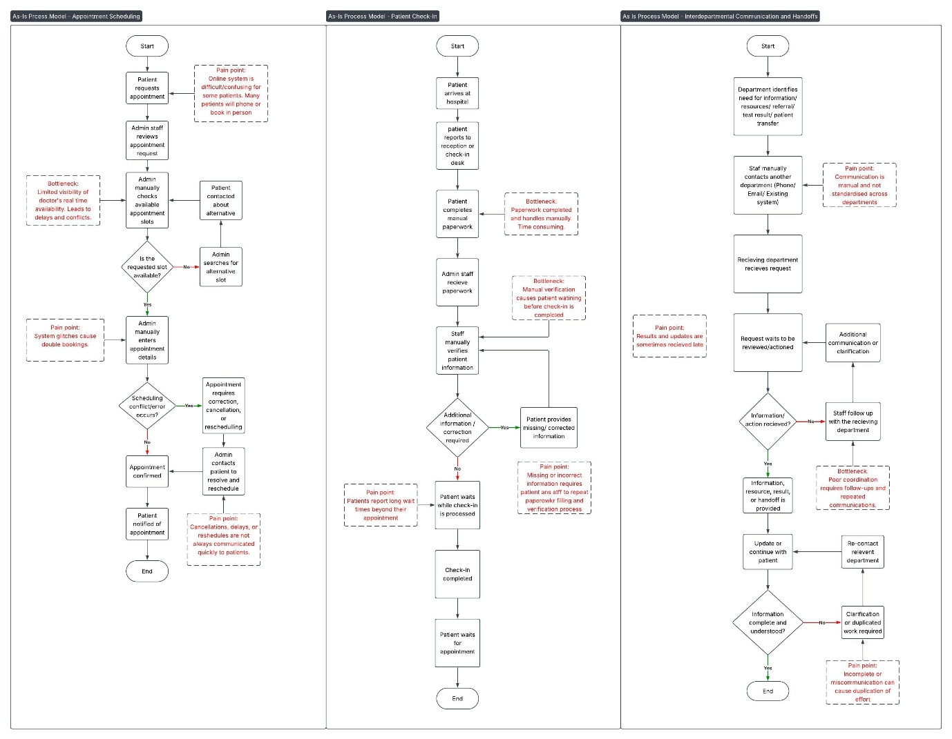
As-Is Process Models:

To-Be Process Models:

Process Models have been modelled with:
Scheduling process model
- Automated appointment scheduling, including implemented conflict detection and real-time notifications
Patient Check-In
- Streamlined with online/self-service check-in.
Interdepartmental communication and handoff
- Improved with automated task management tool or dashboard for resource allocation and issue tracking

